**Computer Networks**

LAB Manual 04

**Objectives:**

**4.1 Dynamic Host Configuration Protocol (DHCP) Configuration by using a Server and a Cisco Switch through Packet Tracer**

**4.2 Setting up FTP Server in Windows 10 and Packet Capturing**

**4.1 Dynamic Host Configuration Protocol (DHCP) Configuration by using a Server and a Cisco Switch through Packet Tracer**

**PREREQUISITES:** Laptop / PC, Cisco Packet Tracer Simulation Software.

**Procedure / Steps**

**Through Cisco Packet Tracer:**

**Step 1:** Open Cisco Packet Tracer Application and login with your netacad credentials. If you don’t have netacad account, then you must create it first.

**Step 2:**  Go to network devices option at the left bottom of packet tracer screen and choose Hub as a network device.

**Step 3:**  Go to end devices option at the left bottom of packet tracer screen and choose Five Devices (PCs) from there.

**Step 4:**  Choose the right cable connection (Straight Through) as you are connecting two different devices this time and appropriate port in PC and network hub as well.

**Step 5:**  Add a server device from **“End Devices”** option where you have selected the PC and connect it with the hub like you connected the PCs with it.

**Step 6:**  Double click on the Server and go to interface setting and assign the following IP address to the server.

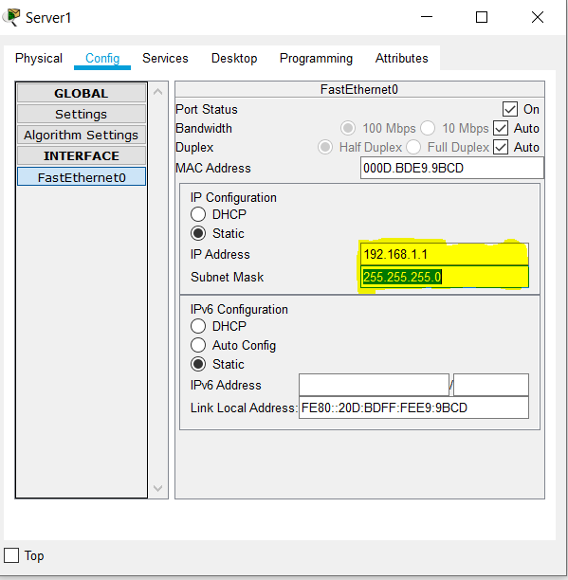

**Step 7:**  Go to the services and then click on the “**DHCP”** option at left.

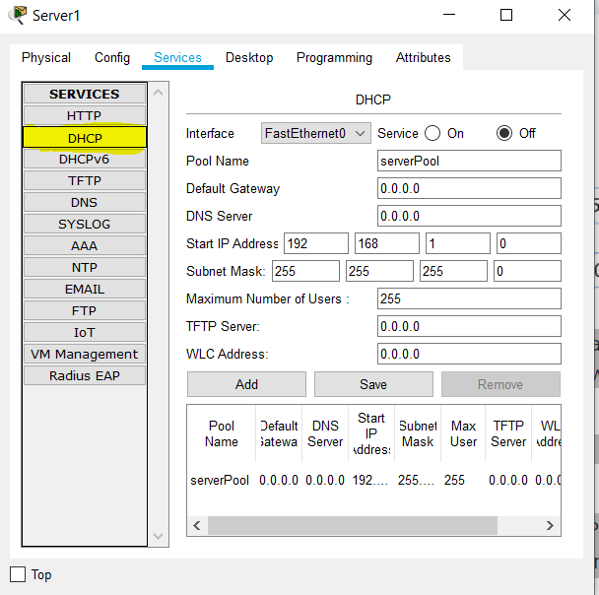

**Step 8:**  Configure the following DHCP setting and then click on the **“Save”** button.

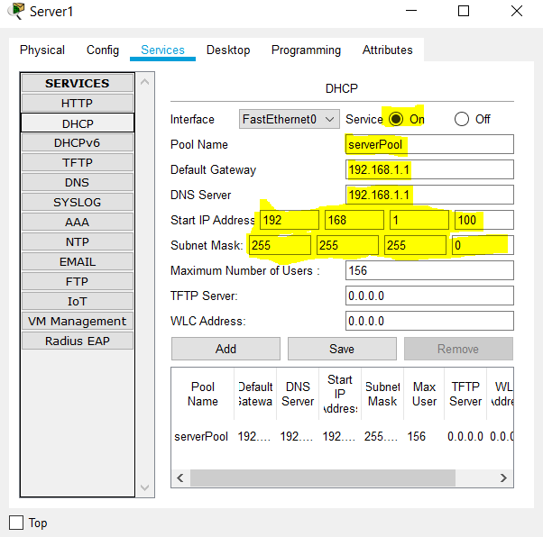

**Step 9:**  Double click on PC and then go Desktop and click on IP configuration.

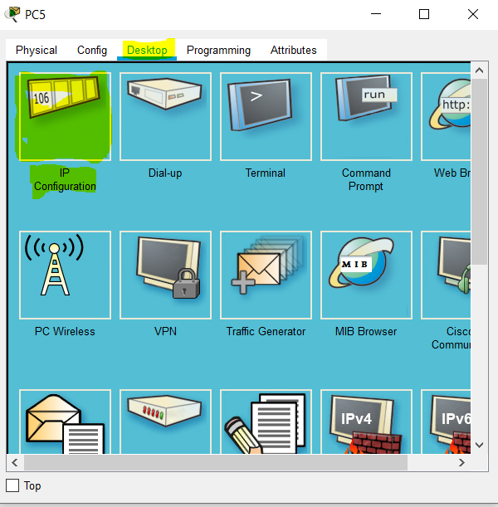

**Step 10:**  Click on **“DHCP”,** wait for some moment, the DHCP server will assign the IP address automatically to the PC from the pool that configured in Step 8.

**Note: Repeat the Step 10 for other PCs as well.**

**Through Cisco Switch:**

**Step 1:** Open Cisco Packet Tracer Application and login with your netacad credentials. If you don’t have netacad account, then you must create it first.

**Step 2:**  Go to network devices option at the left bottom of packet tracer screen and choose Switch as a network device.

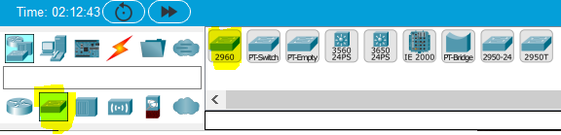

**Step 3:**  Go to end devices option at the left bottom of packet tracer screen and choose Five Devices (PCs) from there.

**Step 4:**  Choose the right cable connection (Straight Through) as you are connecting two different devices this time and appropriate port in PC and network hub as well.

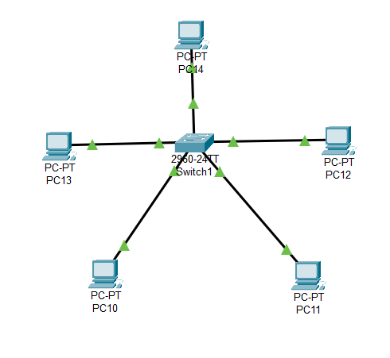

**Step 5:**  Double click on the Switch and go to **CLI** tab and click on it.

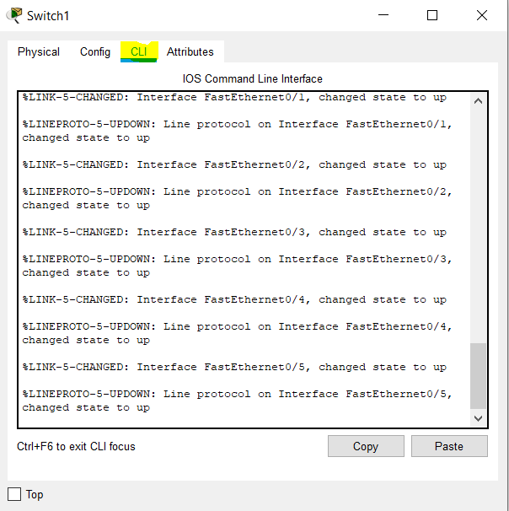

**Step 5:**  Double click and press “Enter” in the “IOS Command Line Interface area and do the following configuration.

Switch>enable

Switch#configure terminal

Switch(config)#interface vlan 1

Switch(config-if)#ip address 192.168.1.1 255.255.255.0

Switch(config-if)#no shutdown

Switch(config-if)#exit

Switch(config)#ip dhcp pool CN-LAB

Switch(dhcp-config)#network 192.168.1.100 255.255.255.0

Switch(dhcp-config)#default-router 192.168.1.1

Switch(dhcp-config)#dns-server 192.168.1.1

Switch(dhcp-config)#exit

Switch(config)#ip dhcp excluded-address 192.168.1.1

Switch(config)#exit

Switch#copy running-config startup-config

**Step 6:**  Double click on PC and then go Desktop and click on IP configuration.



**Step 7:**  Click on **“DHCP”,** wait for some moment, the DHCP server will assign the IP address automatically to the PC from the pool that configured in Step 7.

**Note: Repeat the Step 7 for other PCs as well.**

**4.2 Setting up FTP Server in Windows 10 and Packet Capturing**

**Procedure / Steps**

**5.1.1 Setting Up FTP Server in Windows 10:**

**Step 1:**  Create a new folder with “FTP” name on the desktop.

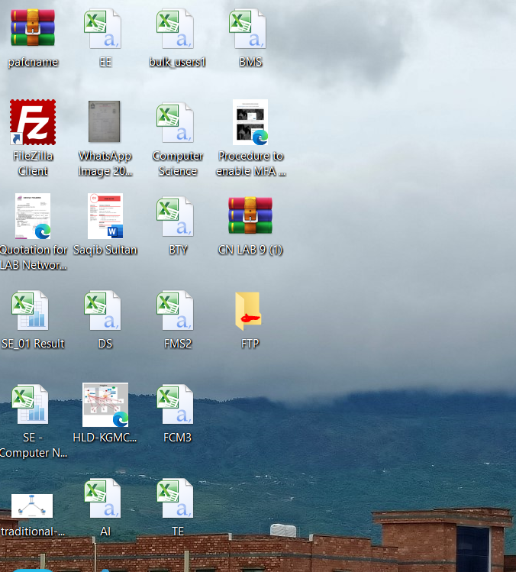

**Step 2:**  Go to the folder properties, then security tab and set the permission for FTP folder. In below snapshot I have given full control to a user “Hafiz Adil Rasheed”. You need to set it accordingly.

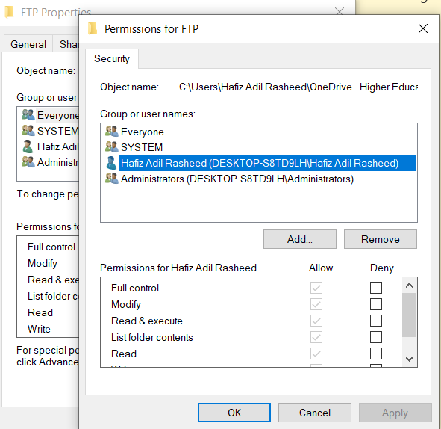

**Step 3:**  The third step is open **control panel** of windows 10 and then “**Programs and Features.”** And then click on **“Turn windows features on or off.”**

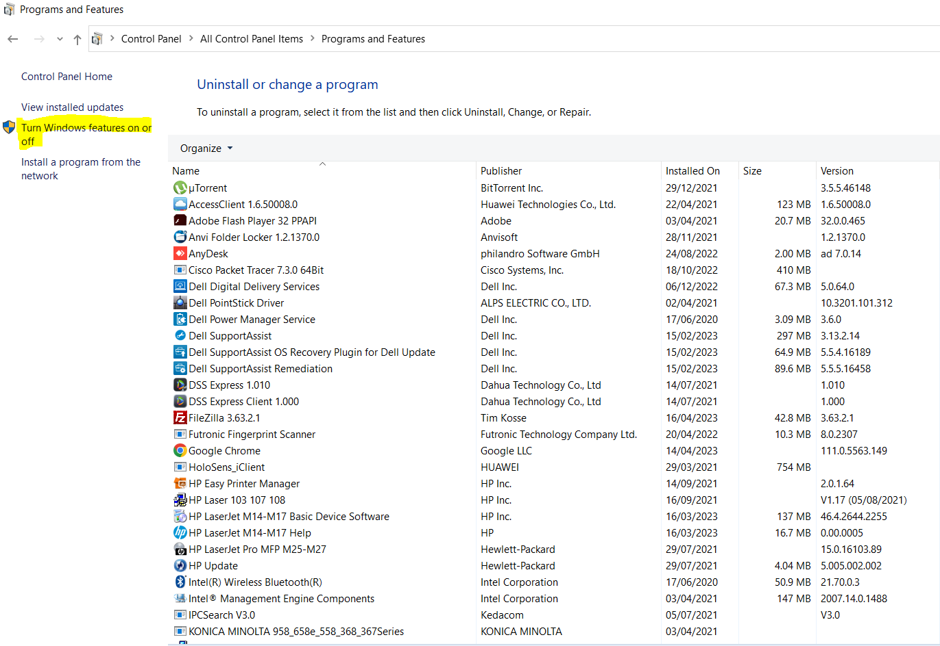

**Step 4:**  In **“Windows Features”** windows select and expand “**Internet Information Services**”. Check the **“FTP Extensibility”** and **“FTP Services”** and then click on **OK** button.

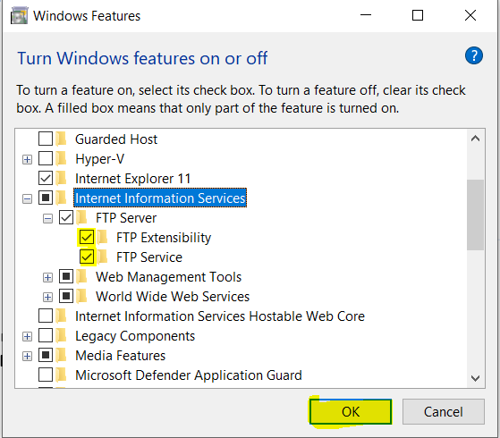

**Step 5:**  Go to **control panel** of windows 10 and then click on **“Administrative Tools”.**

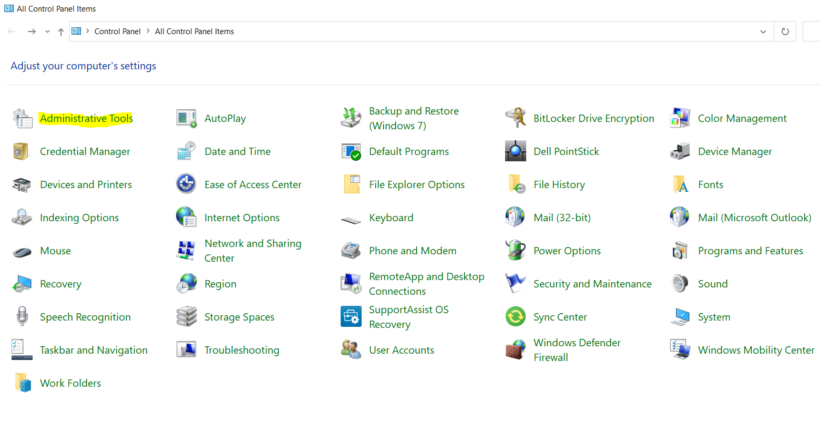

**Step 6:**  In **Administrative Tools”** doble click on **Internet Information Services (IIS) Manager.**

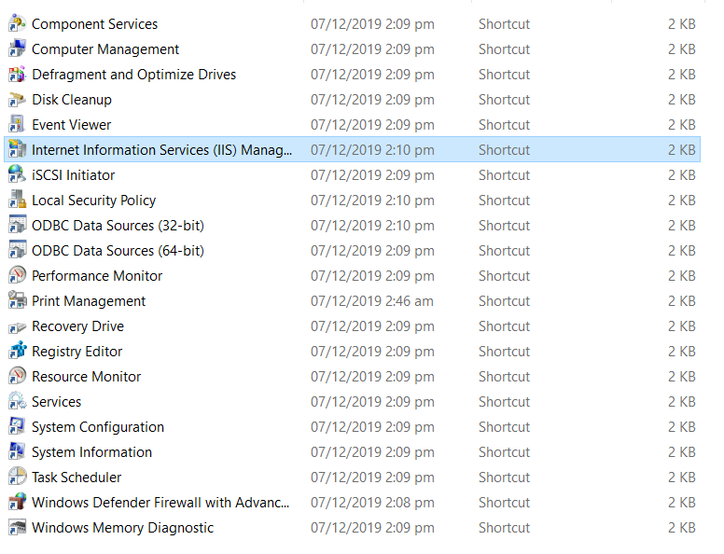

**Step 6:**  On the left under **“Connections”,** expand your PC name.

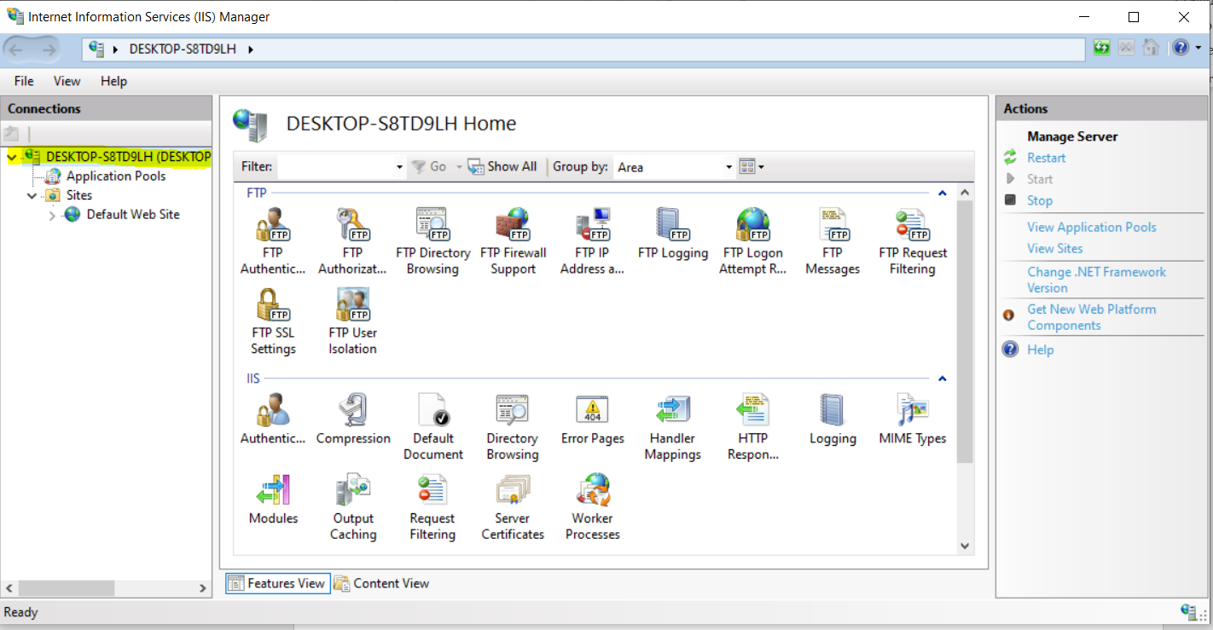

**Step 7:**  Right click on the “**Sites**” tab in Internet Information Services (IIS) Manager and then click on **“Add FTP Site..”**

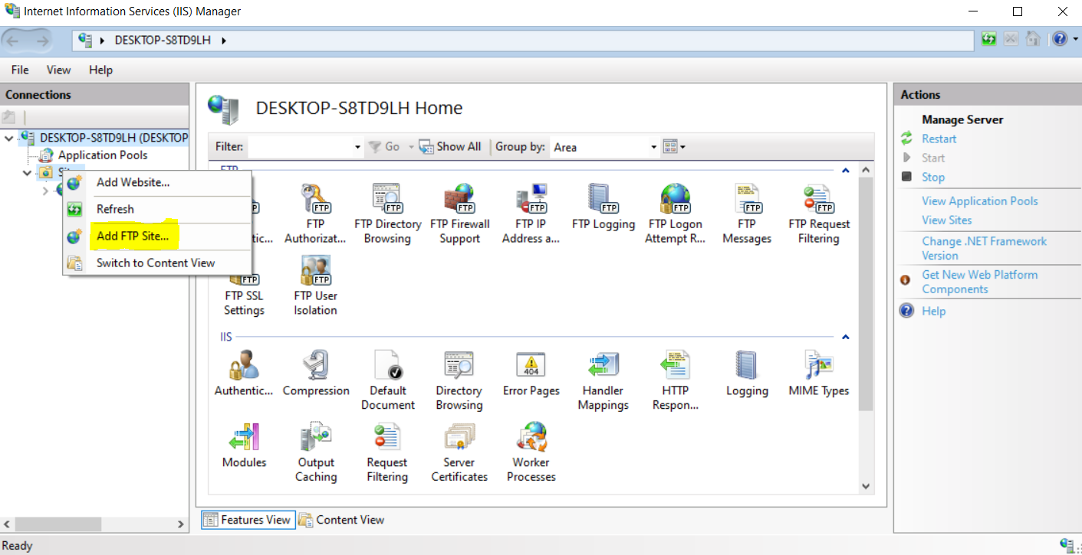

**Step 7:**  Enter FTP Site name as **“CN-LAB”** and give the physical path of **“FTP”** folder created earlier and then click on **Next**.

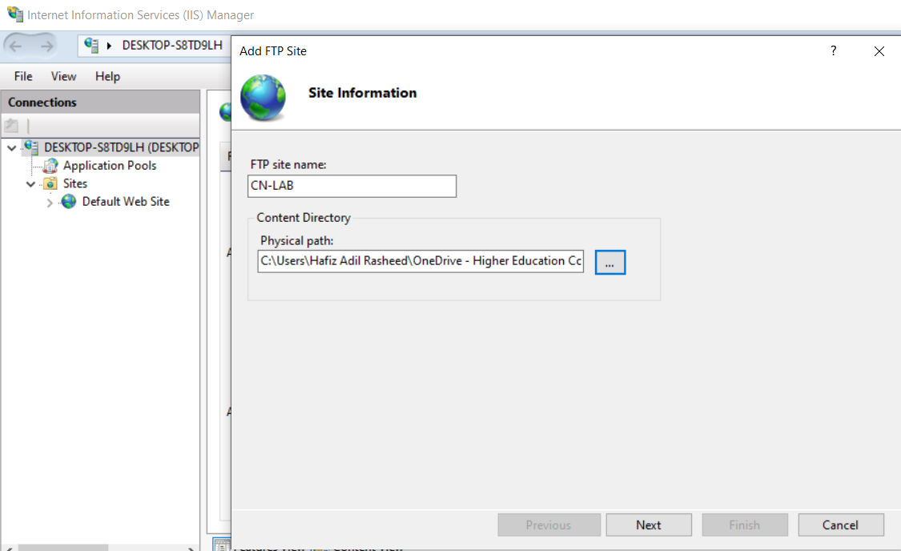

**Step 8:**  In Binding and SSL setting, do the following setting demonstrated below.

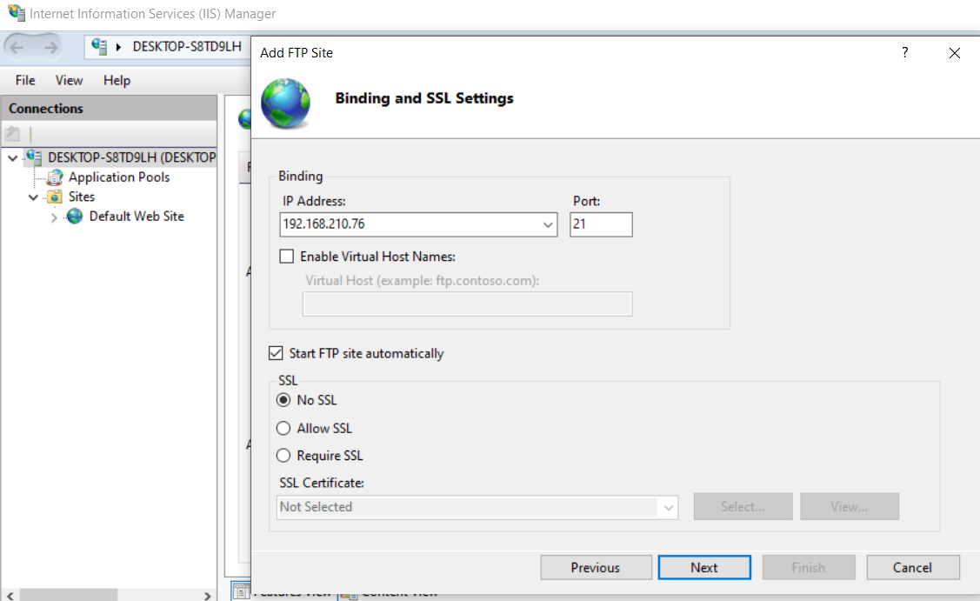

**Step 9:**  In “**Authentication and Authorization Information”** do the following setting demonstrated below and click on **Finish** button.

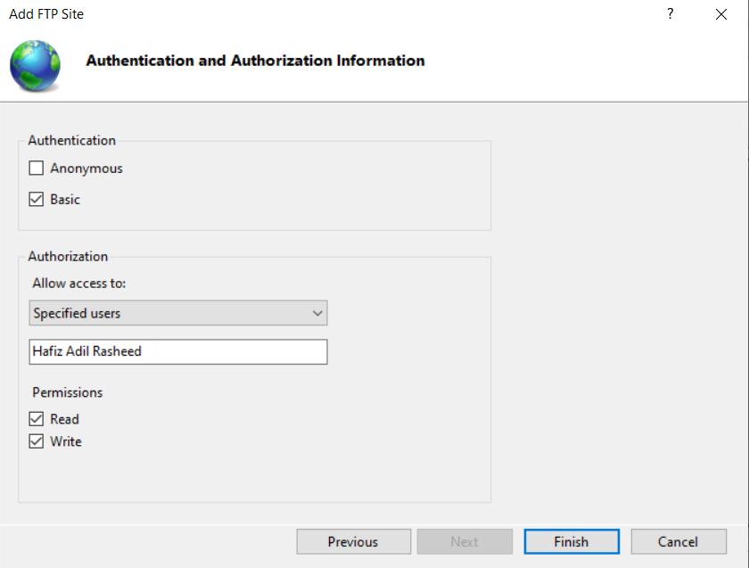

**Step 10:**  The FTP server is now successfully has been added.

**Step 11:**  Check the FTP Services with the help of a third-party FTP client. We are using **“Filezilla Client”** in this lab.

**Step 12:**  Open the **“Filezilla Client”** and enter the following **Host (IP address of FTP Server)** , **Username (Authorized User defined in FTP Server),** **password and port (21)** and then click on “**Quickconnect”**

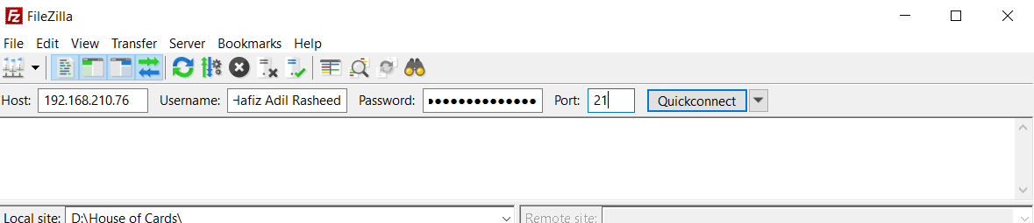

**Step 13:**  The connection has now been established between FTP Server and FTP client. Now you can upload and download data.